Mapping for a Change
Software Project Management Plan

i-Search Kelowna
Mapping for a Change
Tim
12 Feb 2018
Version 1.0

______________________________
[Project Lead Signature Block]

______________________________
[Project Manager Signature Block]

Table of Contents
1 Introduction 1
1.1 Identification 1
1.2 Scope 1
1.3 Document Overview 2
1.4 Relationship to Other Plans 2
2 Acronyms and Definitions 3
3 References 3
4 Overview 3
4.1 Relationships 3
4.2 Source Code 3
4.3 Documentation 3
4.4 Project Resources 4
4.5 Project Constraints 5
5 Software Process 5
5.1 Software Development Process 5
5.1.1 Life Cycle Model 5
5.2 Software Engineering Activities 5
5.2.1 Handling of Critical Requirements 5
5.2.2 Recording Rationale 6
5.2.3 Computer Hardware Resource Utilization 6
5.2.4 Reusable Software 6
5.2.5 Software Testing 6
6 Schedule 7
Appendix A Software Quality Assurance 8
Appendix B Software Configuration Management 9
Appendix C Risk Tracking / Project Oversight 10
Appendix D Software Requirements Specification 11
Requirements Traceability Matrix 14

Revision Sheet

Revision Number | Date | Brief Summary of Changes
1.0 | Feb 12 2018 | Baseline document draft
2.0 | Feb 28 2018 | Edits made, information added
3.0 | April 2 2018 | Document finalized

Introduction

This software gives a comprehensive view of all shelters in Kelowna for people in need of housing. The list can be accessed by employees of a shelter to help direct their clients to appropriate services based on parameters like age, gender etc. Additionally, the software addresses the need for companies / shelters to keep track of what resources are currently available and has the ability to update the data in real time should availability change. Currently, there is no way to efficiently access this information.

An alternative solution to keep track of the shelter information would be to keep the data in a shared document that all shelter workers have access to. However all other shelters would be able to view the status of supplies for other shelters and information would be hard to update and there would be no way to narrow down shelters based on search paramenters. Our solution would increase the efficiency of accessing data and give the functionality to narrow down results using paramaters.

Identification
This document applies to the software development effort in support of the development of Mapping for Change Version 1.0 . A detailed development timeline in support of this effort is provided in the supporting project Master Schedule.

Scope
Mapping for a Change was developed for the i-Search Kelowna. This software allows users to access a list of available housing options that fits their requirements. It also will allow organizations to see what resources are available in the region.

Document Overview
[This subsection should summarize the purpose, contents, and any security or privacy issues that should be considered during the development and implementation of the SPP. It should specify the plans for producing scheduled and unscheduled updates to the SPP and methods for disseminating those updates. This subsection should also explain the mechanisms used to place the initial version of the SPP under change control and to control subsequent changes to the SPP. An example follows:

The purpose of the Mapping for a Change Software Development Plan (SDP) is to guide i-Search Kelowna project management during the development of the MFC reporting software. Software Quality Assurance (SQA) procedures are captured in Appendix A of the SDP. Appendix B is used to document Software Configuration Management (SCM) activities where these activities deviate from MFC SCM Plan. Project management and oversight activities (i.e., risk tracking, problem reporting) are documented in Appendix C of the SDP where these activities deviate from the MFC Risk Management Plan. Requirements for the project will be captured in the Mapping for a Change Software Requirements Specification (SRS). This plan will be placed under configuration management controls according the the MFC Software Configuration Management Plan. Updates to this plan will be handled according to relevant SCM procedures and reviews as described in the MFC Software Quality Assurance Plan.]

Relationship to Other Plans
[This subsection should describe the relationship of the SPP to other project management plans. If organizational plans are followed, this should be noted here. An example is provided:

There are several other [Organization Name] documents which support the information contained within this plan. These documents include: [Organization Name] Software Configuration Management Plan, [Organization Name] Software Quality Assurance Plan, and [Organization Name] Metrics and Measurement Plan. Mapping for a Change project specific documentation relating to this plan include: Mapping for a Change Software Requirements Specifications and Mapping for a Change Master Schedule. This plan has been developed in accordance with all [Organization Name] software development processes, policies, and procedures.]

Acronyms and Definitions
MFC – Mapping For Change

References
[This section should identify the specific references used within the SPP. Reference to all associated software project documentation, including the statement of work and any amendments should be included.]

Overview
[This section of the SPP should list the items to be delivered to the customer, delivery dates, delivery locations, and quantities required to satisfy the terms of the contract. This list should not be construed as an official statement of product requirements. It will only provide an outline of the system/software requirements and will reference detailed product requirements outlined in the SRS, Appendix D. An example follows:

The project schedule in support of Mapping for Change was initiated Feb 12 2018 with a target completion date of Feb 12 2018. Incremental product deliveries may be requested, but none are identified at this time. The delivery requirements are to install Mapping for a Change on the current Mapping for a Change external website. Mapping for a Change will be delivered once deployment has occurred, and with Ms. Rempel’s acceptance of the product. Ms. Rempel may request the installation of MFC reporting software at one additional location. A Mapping for a Change users manual shall also be considered to be required as part of this delivery. Detailed schedule guidance is provided by [document name], located [document location]. Detailed requirements information is provided by [document name], located [document location].]

Relationships
[This subsection should identify interface requirements and concurrent or critical development efforts which may directly or indirectly affect product development efforts.]

Source Code
There are no requirements for source code deliverables. If Ms. Rempel requests the source code, it will be delivered via medium of the customer’s choosing.

Documentation
Mapping for Change’s documentation is provided upon submission of the assignment, in hard copy. The customer will also be provided with documentation as well, in a medium of their choosing.

Project Resources
[This section should describe the project’s approach by describing the tasks (e.g., req. -> design -> implementation -> test) and efforts (update documentation, etc.) required to successfully complete the project. It should state the nature of each major project function or activity and identify the individuals who are responsible for those functions or activities.

This section should also describe the make-up of the team, project roles, and internal management structure of the project. Diagrams may be used to depict the lines of authority, responsibility, and communication within the project. Figure 1 is an example of an organizational chart.

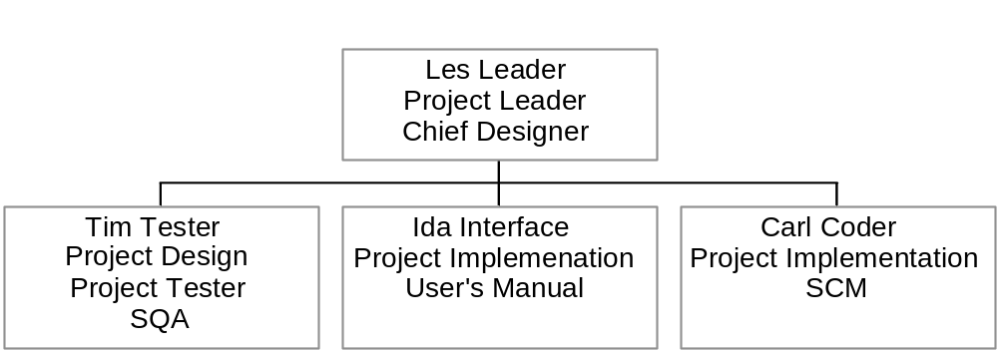
Figure 1. Example Project Organization

The relationship and interfaces between the project team and all non-project organizations should also be defined by the SPP. Minimum interfaces include those with the customer, elements (management, SQA, SCM, etc.), and other support teams. Relationships with other contracting agencies or organizations outside the scope of the project that will impact the project require special attention within this section.]

Project Constraints
[This section should describe the limits of the project including interfaces with other projects, the application of the program’s SCM and SQA (including any divergence from those plans), and the relationship with the project’s customer. This section should also describe the administrative and managerial boundaries between the project and each of the following entities: parent organization, customer organization, subcontracted organizations, or any organizational entities that interact with the project.

This section should capture the anticipated volume of the project through quantifiable measurements such as lines of code, function points, number of units modified, number of pages of documentation generated or changed, etc. It may be useful, if the project is well defined in advance, to breakdown project activities and perform size estimates on each individual activity. This information can then be tied to the project schedule as defined in Section 5.]

Software Process

Software Development Process
[This subsection of the SPP should define the relationships among major project functions and activities by specifying the timing of major milestones, baselines, reviews, work products, project deliverables, and signature approvals. The process model may be described using a combination of graphical and textual notations which include project initiation and project termination activities. The Waterfall Model, Fountain, and ETVX are examples of process models.]

Life Cycle Model
[This subsection of the SPP should identify the life-cycle models used for the software development process. It should describe the project organizational structure, organizational boundaries and interfaces, and individual responsibilities for the various software development elements.]

Software Engineering Activities

Handling of Critical Requirements
[This subsection will identify the overall software engineering methodologies to be used during requirements elicitation and system design. An example is provided:

Please refer to the [Organization Name] Software Requirements Management Plan for information regarding the elicitation and management of customer requirements.]

Recording Rationale
[This subsection should define the methodologies used to capture design and implementation decisions. An example follows:

All initial design and implementation decisions will be recorded and posted in the Mapping for a Change portal project workspace. All formal design documentation will follow the format as described in the [Organization Name] Design Documentation Template.]

Computer Hardware Resource Utilization
[This subsection should describe the approach to be followed for allocating computer hardware resources and monitoring their utilization. Example text is provided:

All computer hardware resource utilization is identified in the Mapping for a Change Spend Plan. Resource utilization is billed hourly as an associated site contract charge. Twenty thousand dollars has been allocated to support the procurement of a development environment. Charges in support of project equipment purchases will be recorded by the Project Manager, [Name], and reported to senior management weekly.]

Reusable Software
[This subsection should describe the approach for identifying, evaluating, and reporting opportunities to develop reusable software products. See the following example:

It is the responsibility of each developer to identify reusable code during the development process. Any item identified will be placed in the [Organization Name] Reuse library which is hosted on the [location]. It is the responsibility of each programmer to determine whether items in the reuse library may be employed during Mapping for a Change development.]

Software Testing
[This subsection should be further divided to describe the approach for software implementation and unit testing. See below:

This project will use existing templates for software test plans and software unit testing when planning for testing. These separate documents will be hosted [location].]

Schedule
[This section of the SPP should be used to capture the project’s schedule including milestones and critical paths. Options include Gantt Charts (Milestones Etc.TM, Microsoft ProjectTM), Pert Charts, or simple time lines. Figure 2 is an example schedule created with Milestones, Etc.TM for a short (two month) project.

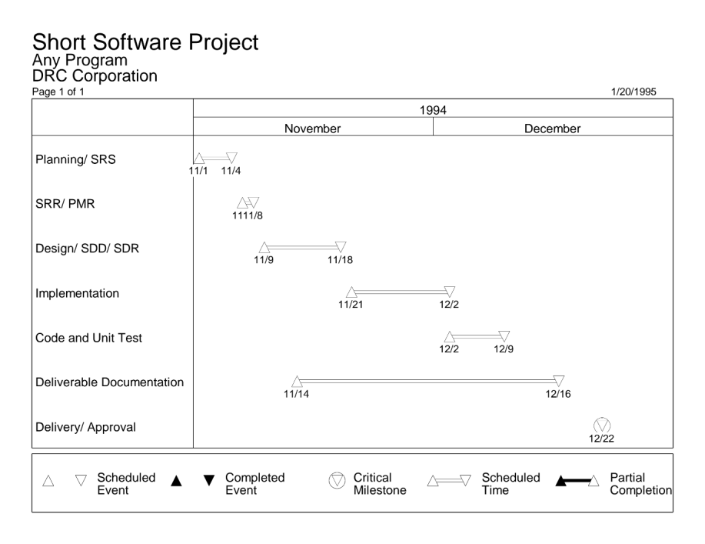
Figure 2. Sample project schedule

]

Appendix A Software Quality Assurance

[This appendix should be divided into the following sections to describe the approach for Software Quality Assurance (SQA):

Software quality assurance evaluations
Software quality assurance records
Independence in software quality assurance
Corrective action

This appendix should reference the organizational, or program, level quality assurance policies, plans and procedures and should detail any deviations from the organizational standard. The following example text is provided:

Refer to the [Organization Name] Software Quality Assurance Plan for all applicable processes and procedures.]

Appendix B Software Configuration Management

[This appendix should be divided into the following sections to describe the approach for Software Configuration Management (SCM):

Configuration identification
Configuration control
Configuration status accounting
Configuration audits
Packaging, storage, handling, and delivery

This appendix should reference the organizational, or program, level configuration management policies, plans and procedures and should detail any deviations from the organizational standard. Please see example text below:

Refer to the [Organization Name] Software Configuration Management Plan for all applicable processes and procedures.]

Appendix C Risk Tracking / Project Oversight
[This appendix should be divided into the following sections to describe the approach for project risk identification and tracking.

Risk management strategies
Identified project risks
Measurement activities

Figure C-1 identifies some measurements that can be made in addition to expended versus expected person-hours for a project. In the example, measurements are tied to the project size and schedule.
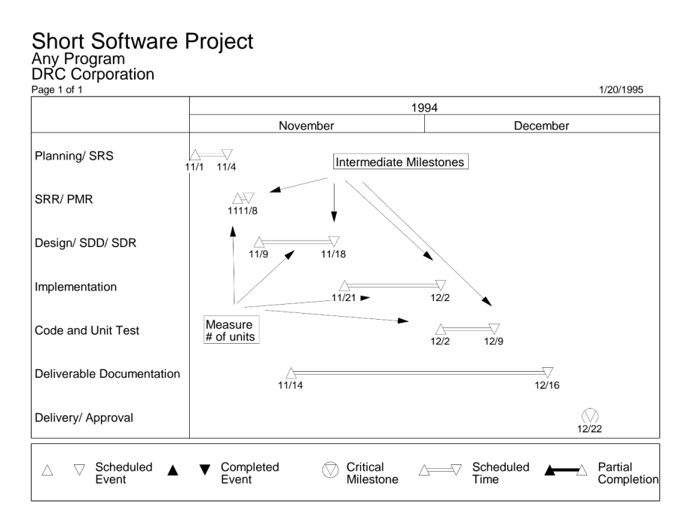
Figure C-1. Sample project measurements

This appendix should reference the organizational, or program, level risk and project management policies, plans and procedures and should detail any deviations from the organizational standard. Sample text below:

Please refer to the [Organization Name] Risk Management Plan for all processes and procedures supporting the tracking of associated project risk.

The following measures will be taken as part of project oversight activities. Please refer to the [Organization Name] Software Project Metrics and Measurement Plan for descriptions.

(list of measures)]
Appendix D Software Requirements Specification

[This appendix is the equivalent of the Software Requirements Specification (SRS) required for large projects. It is produced early in the project life cycle and contains descriptions of all project requirements. A list of characteristics and their definitions for a good SRS are provided in Table 1. These characteristics should be observed as Appendix D is being compiled. This appendix should reference the organizational, or program, level requirements management policies, plans and procedures and should detail any deviations from the organizational standard. If a separate SRS has been created, simply provide a reference to that document.

Table 1. Characteristics of a good SRS
Correct | Every requirement represents a necessary function of the system.
Nonambiguous | Every requirement has one and only one interpretation.
Complete | All requirements are listed and definitions of software responses to all realizable classes of input data and situations are included. NO sections in document marked TBD.
Verifiable | A finite cost effective process exists which can check that the software product meets the requirement.
Consistent | No subset of individual requirements conflict.
Modifiable | Changes can be made easily, completely and consistently.
Traceable | The requirement origin is clear and document structure facilitates future development and enhancement documentation.
Useable during operation and maintenance phases | Modifiable and understandable to user of the SRS.

Functional Requirements

These requirements describe the fundamental actions that must take place within the software or those which specify how the inputs to the software product are transformed into outputs. The following format should be used for each requirement:
A.1.n Requirement n
A.1.n.1 Description
A.1.n.2 Inputs
A.1.n.3 Processing
A.1.n.4 Outputs
where “n” is the number of each requirement. For example, A.1.1 is the first requirement, A.1.1.1 contains the description of the first requirement, A.1.2.1 contains the description for the second requirement, etc.

Description

Section A.1.n.1 provides a description of the purpose of the requirement. This section should contain any background material, approaches or technology employed which might clarify the intent of the function.

Inputs
Section A.1.n.2 provides a detailed description of all data input to include:
- Sources of the input
- Quantities
- Units of measure
- Timing
- Range of valid inputs, including accuracy and tolerances
For a system supporting operator controls (i.e., command post or mission support) the details should include names and descriptions of operator actions and their associated positions.

Processing
Section A.1.n.3 provides all operations to be performed on the input data and intermediate parameters to obtain the output data. This should include:
- Validity checks on the input data
- Exact sequence of operation (including any timing of events required by the project)
- Responses to abnormal situations, for example overflow, communication failures, error handling, etc.
- Parameters affected by the operations
- Any methods which must be used to transform the system inputs into system outputs. This may include algorithms, equations or logical operations
- Validity checks on the output data.

Outputs
Section A.1.n.4 provides detailed descriptions of all data output from the functional requirement including:
- Destinations of the outputs
- Quantities
- Units of measure
- Timing
- Range of valid outputs including accuracy and tolerances
- Disposition of illegal values
- Error messages
References should be made to interface specifications or interface control documents where appropriate.

Non-functional Requirements

Section A.2 should contain any non-functional requirements which do not define the system’s function. Examples of non-functional requirements include timing requirements, security requirements, safety requirements, or system hardware/equipment requirements.]

Requirements Traceability Matrix
XXX Corporation
Requirements Traceability Matrix
(RTM)

Requirement Name | Priority | Risk | SRS Paragraph | Validation Method(s) * | Formal Test Paragraph
Input Personnel Data | H | L | 3.1.1 | A | 6.3.14
Store Personnel Data | M | H | 3.1.2 | A,I | 6.3.17

* Validation Method(s)
D - Demonstration
T - Test
A - Analysis
I - Inspection

Field Descriptions

1. | Requirement Name | A short description of the requirement to be satisfied
2. | Priority | High (H), Medium (M), Low (L); to be negotiated with customer and remains fixed throughout software development lifecycle
3. | Risk | High (H), Medium (M), Low (L); determined by technical staff and will change thoughout software development lifecycle
4. | SRS Paragraph | Paragraph number from section 3 of the SRS.
5. | Validation Method(s) | Method to be used to validate that the requirement has been satisfied.
6. | Formal Test Paragraph | This column will provide a linkage between the SRS and the software Test Plan. This will indicate the test to be executed to satisfy the requirement. (This column will be further defined in later EPG plans.)

